**Philadelphia University**



**Faculty of Information Technology Department of Software Engineering**

**Examination Paper**

**Lecturer :** Dr. M. Maouche

**Coordinator :** Dr M. Maouche

**Internal Examiner :** Dr. A. Moayad

**Course Name**: Software Modeling (721222) **Sections: 2**

**Final Exam**

**First Semester Academic Year:** 2014/15 **Date**: February, 4th , 2015 **Time:** 120 minutes

**Information for Candidates**

1. *This examination paper contains 4 questions totalizing 46 marks.*
2. *The marks for parts of questions are shown in round brackets.*

## Advice to Candidates

*1. You should write your answers precisely, clearly and to the point.*

*2. Draw clear and large model.*

**I. Basic Notions**

**Objectives.** *The aim of the question in this part is to evaluate the required minimal student knowledge and skills. Answers in the pass category represent the minimum acceptable standard.*

**Question1: (14 marks)**

* + - 1. **Name three kinds of events** that may appear in a state diagram. (3 marks).
      2. **Differentiate** the following concepts: **Action** and **Activity.** (4 marks).
      3. **Name** three kinds of **modeling views/aspects.** (3 marks)

4. **Fill the blank** in the following statement: ‘State diagrams are used

to describe____________________________’ (2 marks)

5. **Name** two kinds of **styles** that are used to **describe use case flows**. (2 marks).

**II. Familiar Problems Solving**

***Objectives****. The aim of the question in this part is to evaluate that the student has some basic knowledge of the key aspects of the lecture material and can attempt to solve familiar problems.*

**Question2: (16 marks)**

A video sales and rental shop wishes to automate its management of sales and rental of its movie videos. The video shop distinguishes between ordinary customers and members. Members are special customers who own an annual subscription card.

The following are **two high level use cases** of the system:

**Buy video:** allows a **customer** (via the Web) or a **staff** (in the shop) to select a video and its quantity for purchase and **staff** to look up customer/member information

**Rent video:** allows a **customer** (via the Web) or **staff** (in the shop) to **select a video** for rental, **staff** to **return rented videos** and to **look up customer/member information**, and the **system** to **record which copy of a video has been rented**, **keep track of overdue videos**, and **produce notices** for customers with overdue videos.

**A- Use Case Modeling**: (11 marks)

Give the actors of the system. (2 marks)

Link these actors with the associated use cases mentioned above. (2 marks)

Refine the high level use case **Rent Video** into a set of low level use cases.

(2 marks)

Draw the relationships between the **Rent Video** use case and its associated low

level use cases. (2 marks)

Describe the **Return rented videos** low leveluse case:

trigger event, pre-condition (s), post-condition (s), list of exceptions. (3 marks)

**B- Class Diagram:**  (5 marks)

Draw a class diagram that involves the following classes: **Movie-Shop, Movie-Rent,**

**Movie, Movie-Buy.**

**Question3: (10 marks)**

Consider the following scenario that describes a **voting task:**

Once arrived at the polling station, elector gives the own electoral card to station president who checks if the polling station number is right.

Then he checks the identity document and if ok he gives the ballot paper to the elector.

Then the president waits for a cabin to get free and he gives the pencil to the elector and a secretary who signs the registry and put a print on the elector certificate.

Once elector has voted, he/she inserts the ballot paper in the urn, giving back the pencil and taking back the own ID document.

**Draw a complete activity diagram** that describes the above voting scenario. Parallel activities, if any, need to be shown in the diagram.

**III. UnFamiliar Problem Solving**

***Objectives****. The aim of the question in this part is to evaluate that the student has some basic knowledge of the key aspects of the lecture material and can attempt to solve unfamiliar problems.*

**Question4: (6 marks)**

The following describes the use case **Purchase One Way Ticket** provided by a ticket distributor machine.

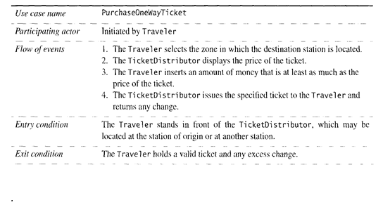

**Draw a sequence diagram associated with this use case.**

The desired sequence diagram will involve the following:

**Static objects**: Traveler, TicketDistributor, Zone, Balance

**Dynamic object:** Ticket